# Installation guide of Teraform (Windows).

# Step 1: Download terraform

To install Terraform, First Download the Terraform Cli Utility for windows

from terraforms official website

website:<https://www.terraform.io/downloads.html>

Select the Operating System Windows followed by either 32bit (386) or 64 bit (AMD64) based

on your OS type.

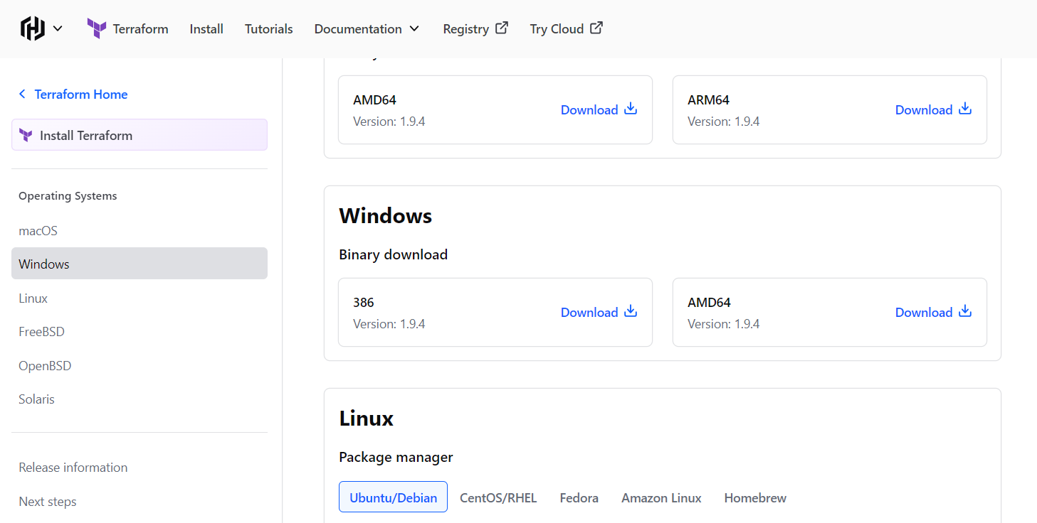

# Step 2: Create a folder for Terraform:

* Open **File Explorer** and navigate to C:\ or another location where you want to store Terraform.
* Right-click in the folder, select **New > Folder**, and name the folder something like Terraform.
* For example, the folder might be C:\Terraform.

# Step 3: Extract Terraform into this folder:

* Make sure to move the zip file from downloads to this new folder if it is not there already.
* After downloading the .zip file, right-click the .zip and choose **Extract All**.
* Extract the contents of the .zip file into the folder you just created (e.g., C:\Terraform).

*the background is the terraform folder in the c drive where we unzip the file and the forefront image is of contents inside this unzipped folder.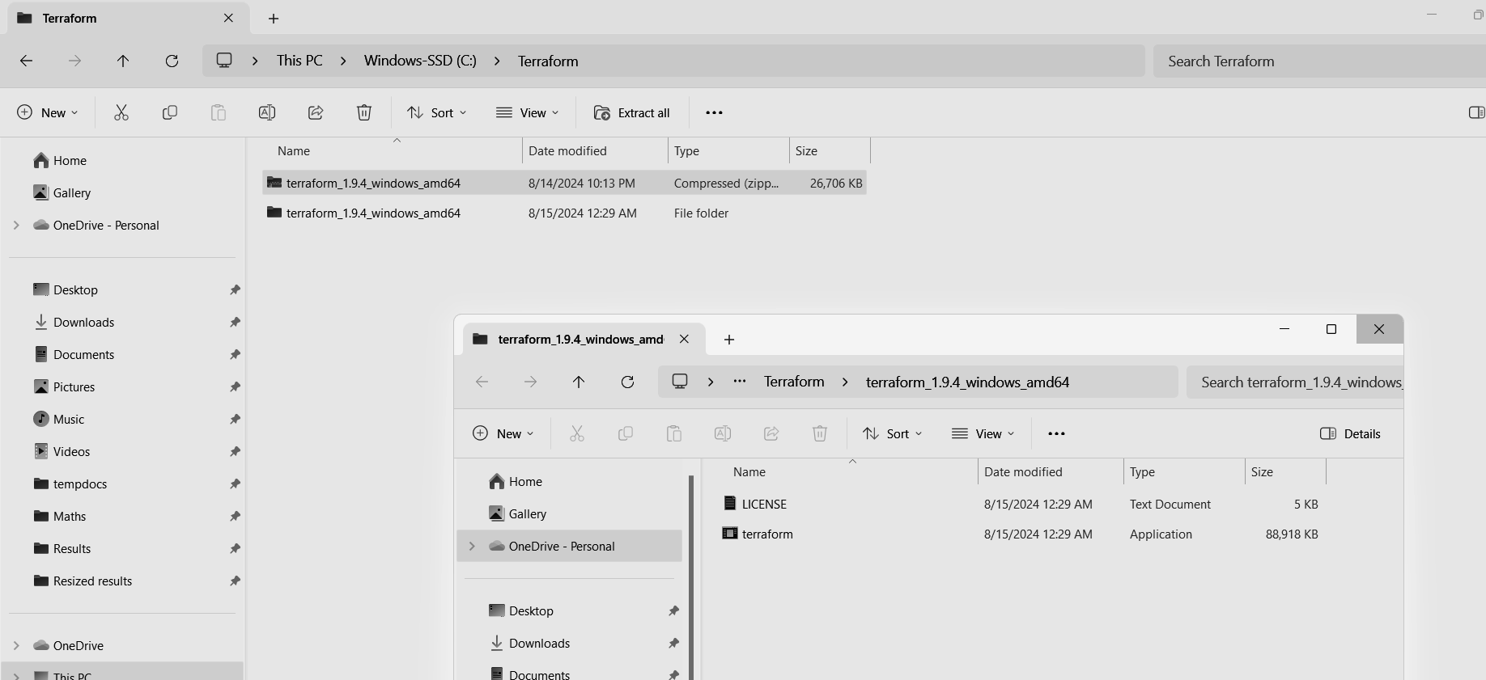

# Step 4: Add to path

* Theory : the system uses top level search for finding the executable files, so rule of thumb is to add the directory which is a direct parent to the terraform exe.
* Hence, we first locate the terraform.exe and only copy the path till its parent directory.

the highlighted file is the executable file and we will just copy that terraform_1.9.4_windows_amd64 visible in the path above.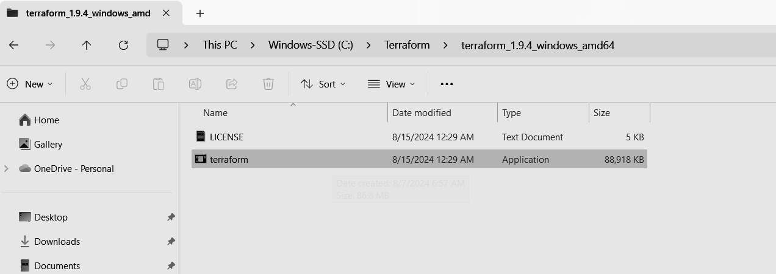

* Now search for edit environment variables and click on it.
* Now click on environment variables.

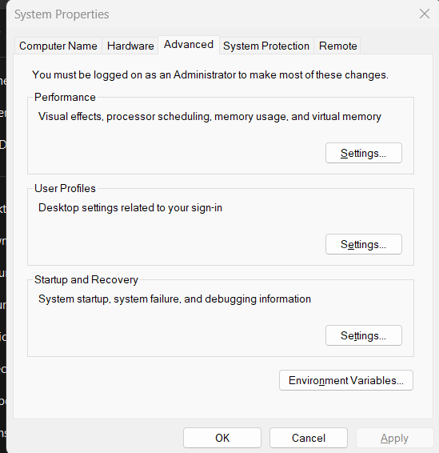

* Now select path from the system variables and click on edit.

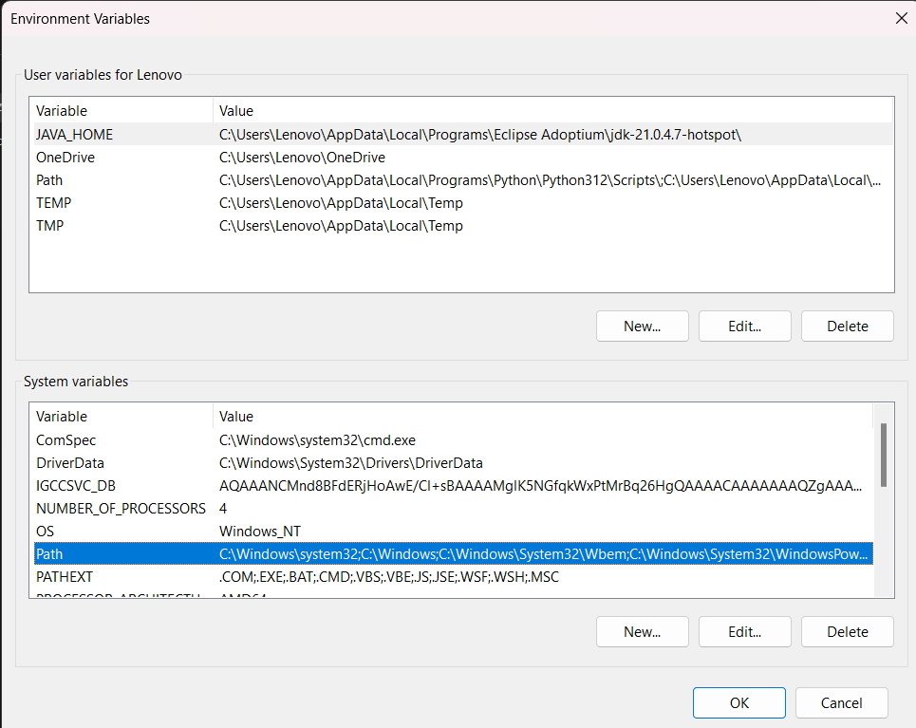

*Note click on edit and not new!

* Now paste the path to the directory that we copied.

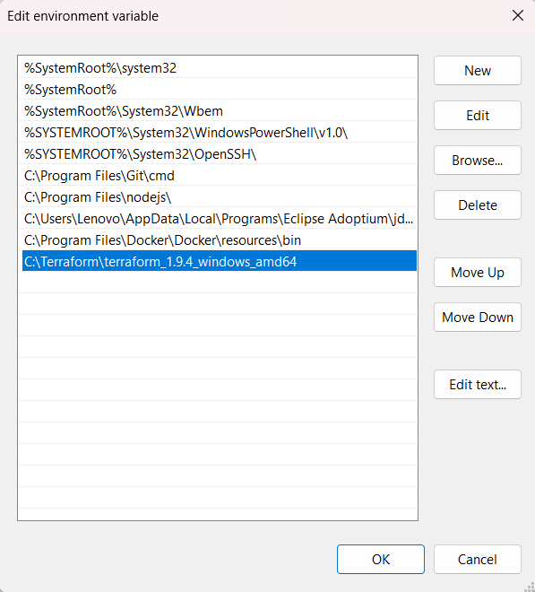

# Step 5: Run terraform command in shell to see if it works

